|  |
| --- |
| **VISVESVARAYA TECHNOLOGICAL UNIVERSITY**    **“JnanaSangama”, Belgaum -590014, Karnataka.**    **LAB RECORD**    **Bio Inspired Systems (23CS5BSBIS)**  ***Submitted by***  **ROHAN VATS (1BM23CS273)**  ***in partial fulfillment for the award of the degree of***    **BACHELOR OF ENGINEERING**  ***in***  **COMPUTER SCIENCE AND ENGINEERING**          **B.M.S. COLLEGE OF ENGINEERING**  **(Autonomous Institution under VTU)**  **BENGALURU-560019**  **Aug-2025 to Dec-2025** |

**B.M.S. College of Engineering,**

**Bull Temple Road, Bangalore 560019**

(Affiliated To Visvesvaraya Technological University, Belgaum)

# Department of Computer Science and Engineering



## CERTIFICATE

This is to certify that the Lab work entitled “Bio-Inspired Systems (23CS5BSBIS)” carried out by **ROHAN VATS (1BM23CS273),** who is a bonafide student of **B.M.S. College of Engineering.** It is in partial fulfillment for the award of **Bachelor of Engineering in Computer Science and Engineering** of the Visvesvaraya Technological University, Belgaum. The Lab report has been approved as it satisfies the academic requirements of the above-mentioned subject and the work prescribed for the said degree.

|  |  |
| --- | --- |
| Swati Sridharan  Assistant Professor  Department of CSE, BMSCE | Dr. Kavitha Sooda  Professor & HOD  Department of CSE, BMSCE |

# Index

|  |  |  |  |
| --- | --- | --- | --- |
| **Sl.**  **No.** | **Date** | **Experiment Title** | **Page No.** |
| 1 | 18/8/2025 | Genetic Algorithm | 4 |
| 2 | 25/8/2025 | Optimization via gene expression | 6 |
| 3 | 1/9/2025 | Particle Swarm Optimization | 11 |
| 4 | 8/9/2025 | Ant Colony Optimization | 14 |
| 5 | 15/9/2025 | Cuckoo search algorithm | 16 |
| 6 | 29/9/2025 | Grey wolf optimizer | 18 |
| 7 | 13/10/2025 | Parallel cellular algorithm | 22 |

Github Link:

https://github.com/rvats15/BISLAB

## Program 1 : Genetic Algorithm

**Problem statement:**

Genetic Algorithms (GA) are inspired by the process of natural selection and genetics, where the fittest individuals are selected for reproduction to produce the next generation. GAs are widely used for solving optimization and search problems.

**Algorithm:**

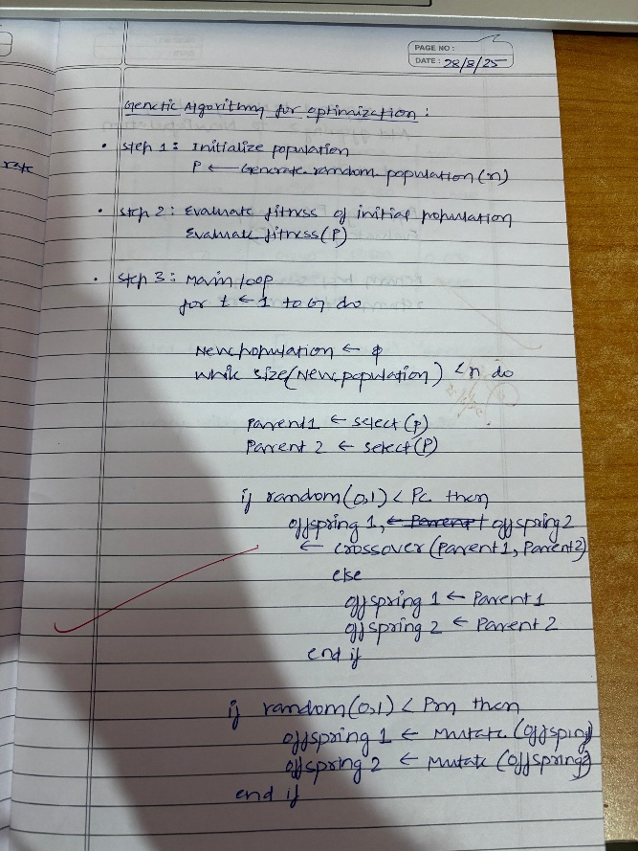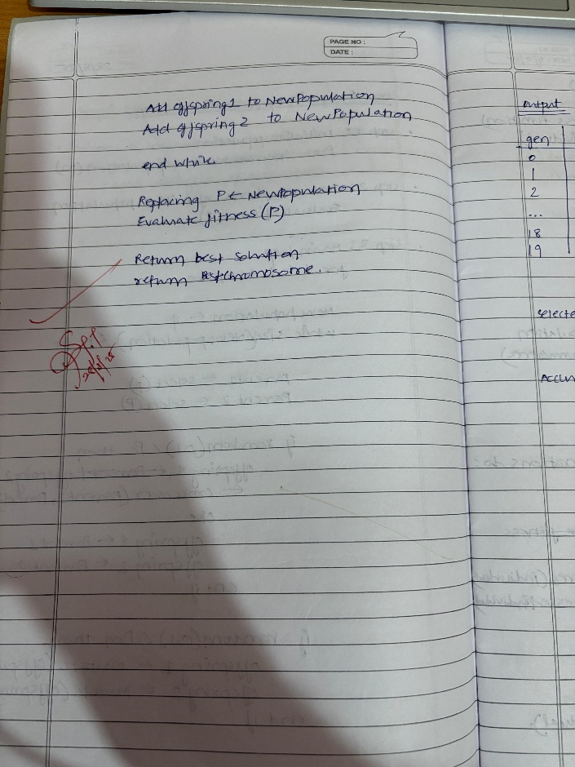

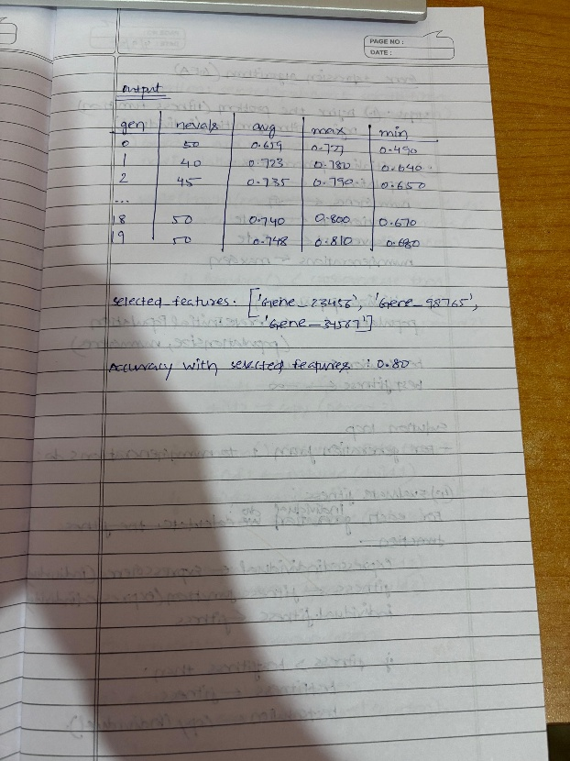

**Code:**

import random def fitness(x): return x**2 def int_to_bin(x):

return format(x, '05b') def bin_to_int(b): return int(b, 2) def tournament_selection(pop, k=3): selected = random.sample(pop, k) selected.sort(key=lambda x: fitness(x), reverse=True) return selected[0] def crossover(p1, p2):

b1, b2 = int_to_bin(p1), int_to_bin(p2) point = random.randint(1, 4) child1 = bin_to_int(b1[:point] + b2[point:]) child2 = bin_to_int(b2[:point] + b1[point:]) return child1, child2 def mutate(x, mutation_rate=0.1): if random.random() < mutation_rate:

b = list(int_to_bin(x)) pos = random.randint(0, 4) b[pos] = '1' if b[pos] == '0' else '0' return bin_to_int("".join(b)) return x

def genetic_algorithm(initial_population=None, pop_size=6, generations=20, crossover_rate=0.8, mutation_rate=0.1): if initial_population:

population = initial_population[:pop_size] # take only needed size else:

population = [random.randint(0, 31) for _ in range(pop_size)] for gen in range(generations):

population.sort(key=lambda x: fitness(x), reverse=True) best = population[0] print(f"Gen {gen}: Best x={best}, f(x)={fitness(best)}") new_pop = [best] while len(new_pop) < pop_size:

parent1 = tournament_selection(population) parent2 = tournament_selection(population) if random.random() < crossover_rate:

child1, child2 = crossover(parent1, parent2) else:

child1, child2 = parent1, parent2 child1 = mutate(child1, mutation_rate) child2 = mutate(child2, mutation_rate) new_pop.extend([child1, child2]) population = new_pop[:pop_size] population.sort(key=lambda x: fitness(x), reverse=True) best = population[0] print(f"\nBest Solution: x={best}, f(x)={fitness(best)}") custom_population = [3, 7, 15, 20, 25, 30] genetic_algorithm(initial_population=custom_population, generations=5)

## Program 2 : Optimization via Gene expression

**Problem statement:**

Gene Expression Algorithms (GEA) are inspired by the biological process of gene expression in living organisms. This process involves the translation of genetic information encoded in DNA into functional proteins. In GEA, solutions to optimization problems are encoded in a manner similar to genetic sequences. The algorithm evolves these solutions through selection, crossover, mutation, and gene expression to find optimal or near-optimal solutions. GEA is effective for solving complex optimization problems in various domains, including engineering, data analysis, and machine learning.

**Algorithm:**

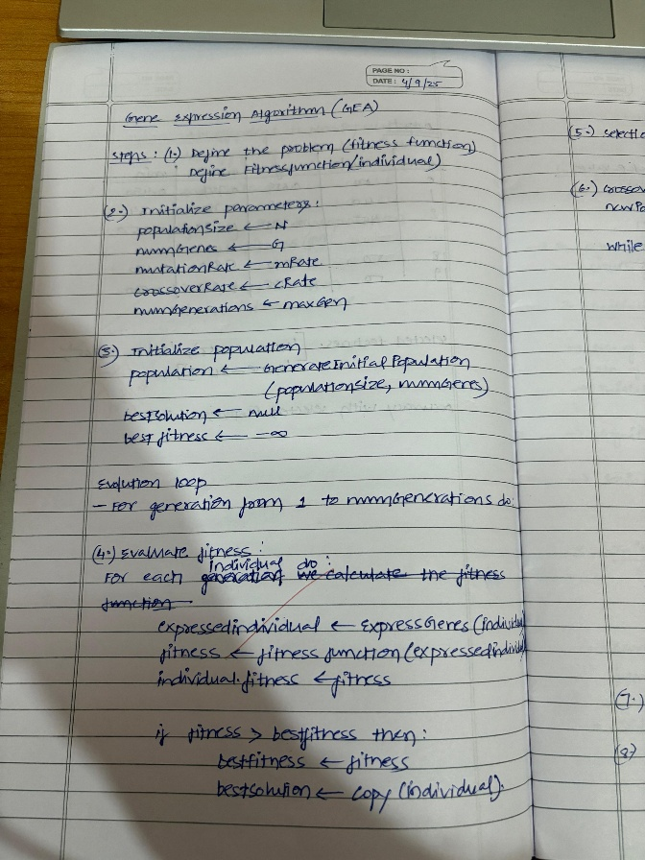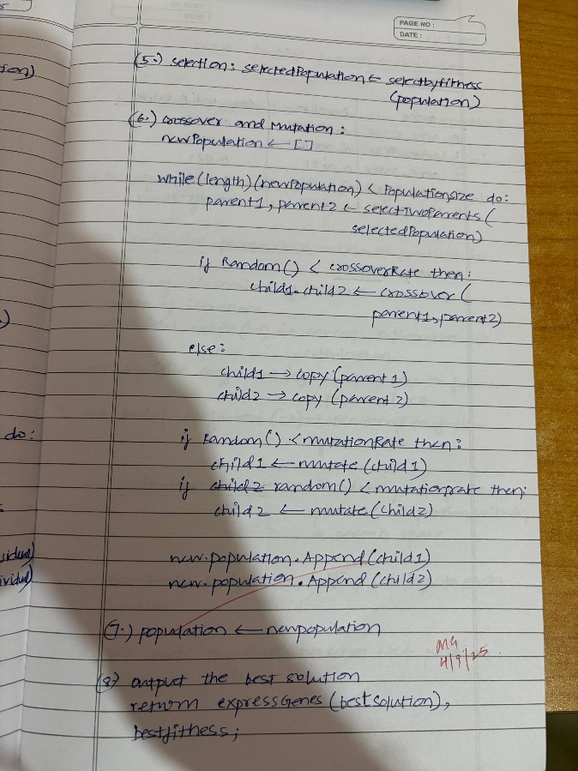

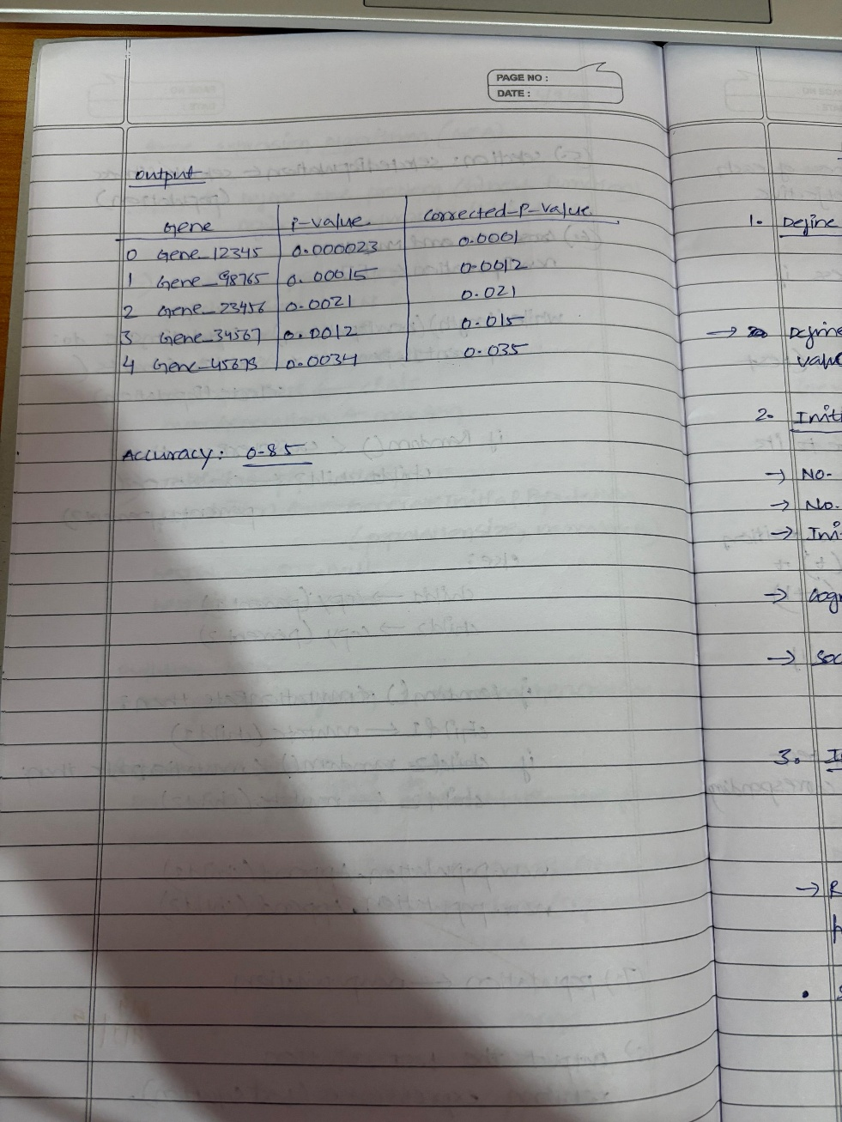

**Code:**

import random import math cities = [

(0, 0), (1, 5), (5, 2), (6, 6), (8, 3),

(2, 1), (7, 7), (3, 3), (4, 4), (9, 0)

]

def distance(a, b):

return math.sqrt((a[0]-b[0])**2 + (a[1]-b[1])**2) def total_distance(tour):

dist = 0

for i in range(len(tour)): city_a = cities[tour[i]] city_b = cities[tour[(i+1) % len(tour)]] dist += distance(city_a, city_b)

return dist def create_individual(n): gene = list(range(n)) random.shuffle(gene) return gene def mutate(individual, rate=0.1):

ind = individual[:] for i in range(len(ind)): if random.random() < rate: j = random.randint(0, len(ind)-1) ind[i], ind[j] = ind[j], ind[i] return ind def crossover(parent1, parent2):

size = len(parent1) a, b = sorted([random.randint(0, size-1) for _ in range(2)]) child = [None]*size child[a:b+1] = parent1[a:b+1] p2_index = 0 for i in range(size): if child[i] is None: while parent2[p2_index] in child:

p2_index += 1 child[i] = parent2[p2_index] return child def genetic_algorithm(generations=100, pop_size=100, mutation_rate=0.1): num_cities = len(cities) population = [create_individual(num_cities) for _ in range(pop_size)] best = None best_dist = float('inf') for gen in range(generations):

scored = [(ind, total_distance(ind)) for ind in population] scored.sort(key=lambda x: x[1]) if scored[0][1] < best_dist: best = scored[0][0] best_dist = scored[0][1] new_pop = [best] while len(new_pop) < pop_size:

p1 = random.choice(scored[:50])[0] p2 = random.choice(scored[:50])[0] child = crossover(p1, p2) child = mutate(child, mutation_rate) new_pop.append(child) population = new_pop if gen % 20 == 0:

print(f"Gen {gen}: Best distance = {best_dist:.2f}")

return best, best_dist best_tour, best_dist = genetic_algorithm() print("\nBest tour found:") print(best_tour) print(f"Total distance: {best_dist:.2f}")

## Program 3 : Particle swarm Optimization

**Problem statement:**

Particle Swarm Optimization (PSO) is inspired by the social behavior of birds flocking or fish schooling. PSO is used to find optimal solutions by iteratively improving a candidate solution with regard to a given measure of quality.

**Algorithm:**

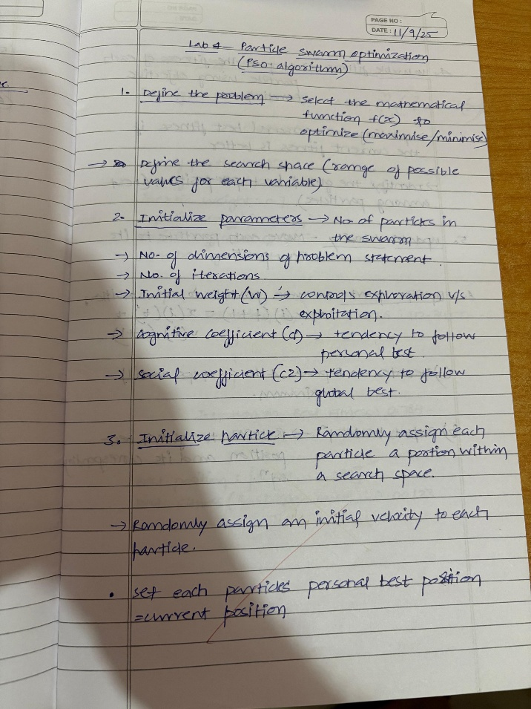 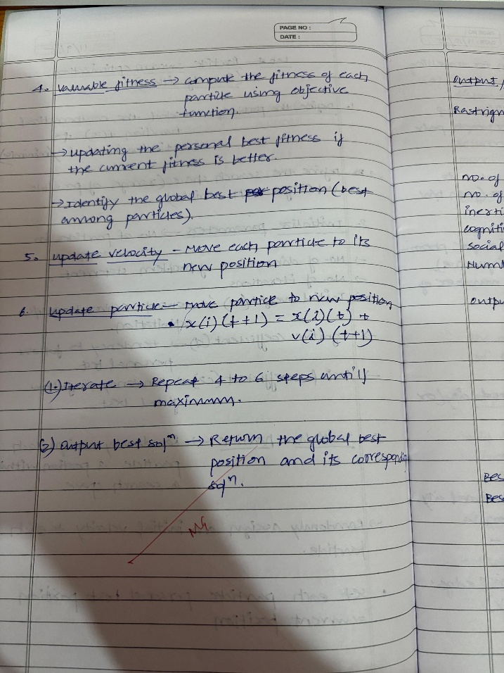

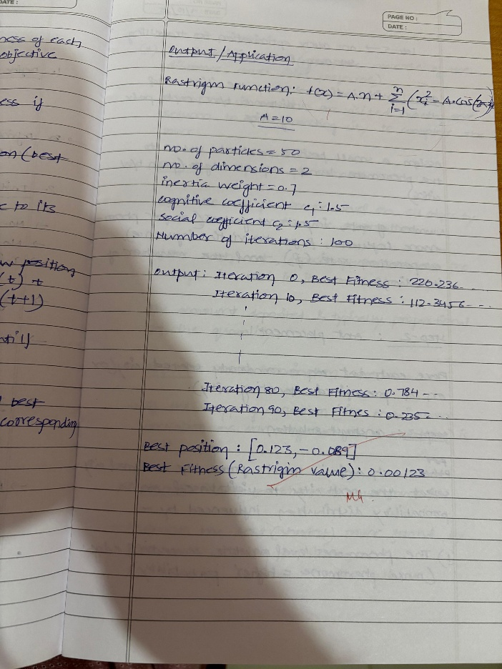

**Code:**

import numpy as np x_data = np.array([1, 2, 3, 4, 5]) y_data = np.array([3, 5, 7, 9, 11]) def objective_function(theta):

theta_0, theta_1 = theta predictions = theta_0 + theta_1 * x_data errors = y_data - predictions return np.sum(errors**2) num_particles = 30 num_iterations = 10

w = 0.7 c1 = 1.5 c2 = 2.1 bounds = [(-10, 10), (-10, 10)] positions = np.array([np.random.uniform(low, high, num_particles) for low, high in bounds]).T velocities = np.random.uniform(-1, 1, (num_particles, 2)) personal_best_positions = np.copy(positions) personal_best_values = np.array([objective_function(p) for p in personal_best_positions]) best_particle_index = np.argmin(personal_best_values) global_best_position = personal_best_positions[best_particle_index] global_best_value = personal_best_values[best_particle_index] for iteration in range(num_iterations): for i in range(num_particles):

fitness = objective_function(positions[i]) if fitness < personal_best_values[i]: personal_best_values[i] = fitness personal_best_positions[i] = positions[i] if fitness < global_best_value: global_best_value = fitness global_best_position = positions[i] for i in range(num_particles): r1 = np.random.rand(2) r2 = np.random.rand(2) cognitive = c1 * r1 * (personal_best_positions[i] - positions[i]) social = c2 * r2 * (global_best_position - positions[i]) velocities[i] = w * velocities[i] + cognitive + social positions[i] += velocities[i] for dim in range(2):

positions[i, dim] = np.clip(positions[i, dim], bounds[dim][0], bounds[dim][1]) print(f"Iteration {iteration+1}/{num_iterations}, Best SSE: {global_best_value:.5f}") print("\nBest parameters found:") print("theta_0 =", global_best_position[0]) print("theta_1 =", global_best_position[1]) print("Minimum sum of squared errors:", global_best_value)

## Program 4 : Ant Colony Optimization

**Problem statement:**

The foraging behavior of ants has inspired the development of optimization algorithms that can solve complex problems such as the Traveling Salesman Problem (TSP). Ant Colony Optimization (ACO) simulates the way ants find the shortest path between food sources and their nest. Implement the ACO algorithm using Python to solve the TSP, where the objective is to find the shortest possible route that visits a list of cities and returns to the origin city.

**Algorithm:**

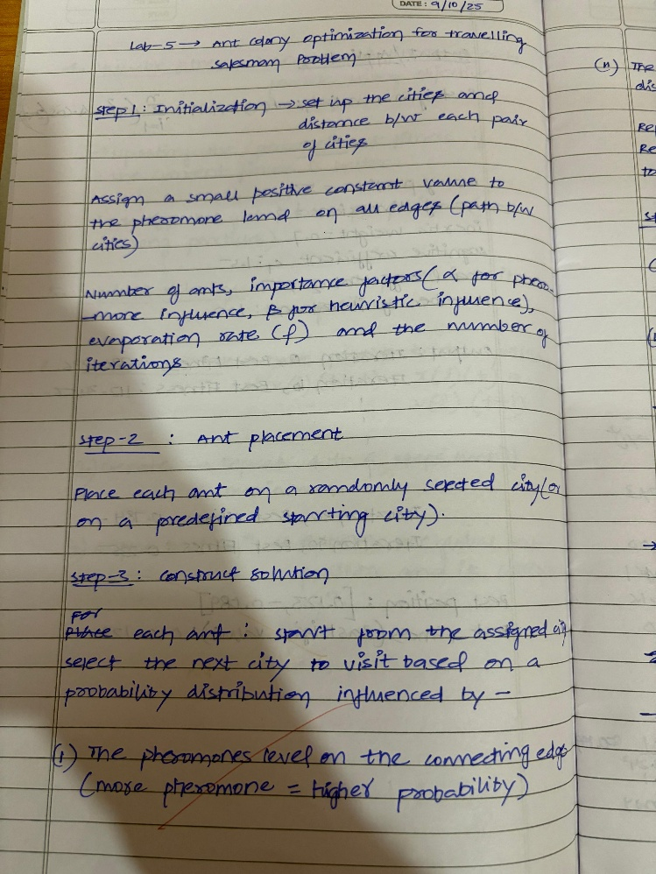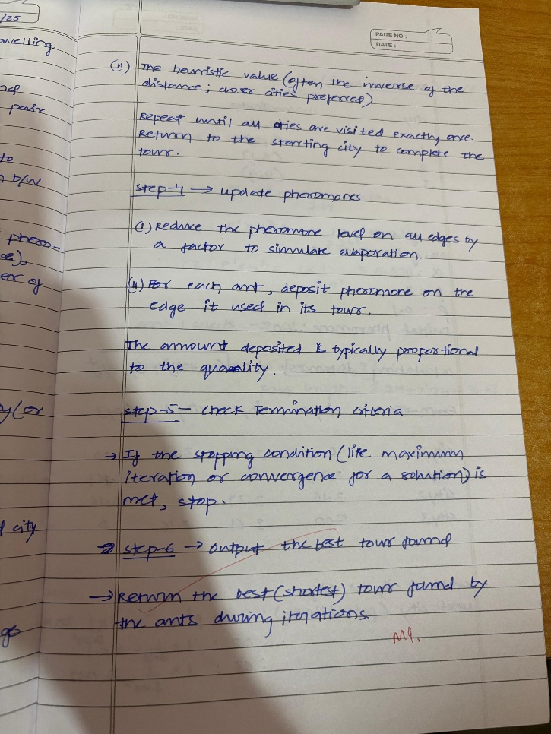

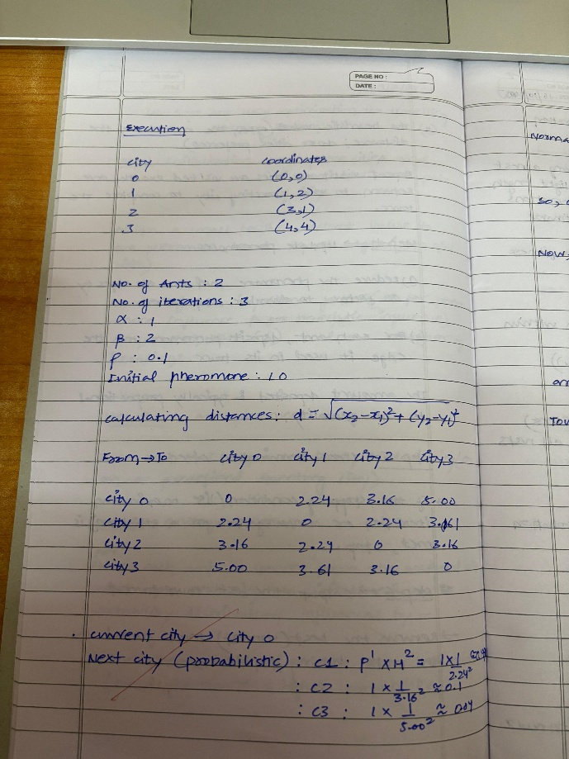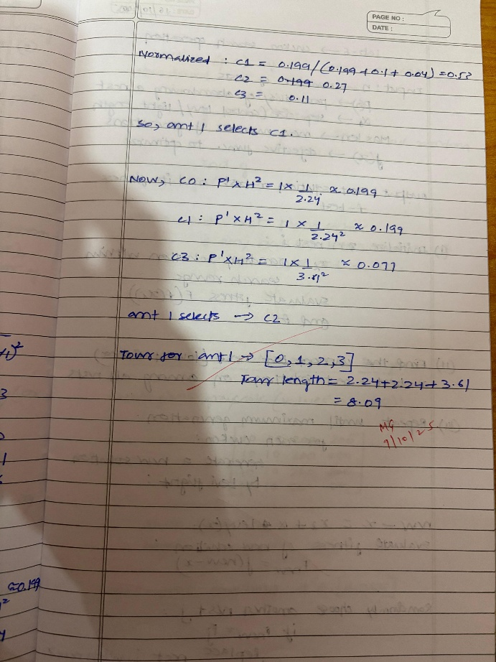

**Code:**

import numpy as np import random NUM_CITIES = 10

NUM_ANTS = 20

NUM_ITERATIONS = 100

ALPHA = 1.0

BETA = 5.0

EVAPORATION = 0.5

Q = 100 np.random.seed(42)

cities = np.random.rand(NUM_CITIES, 2) * 100 dist_matrix = np.sqrt(((cities[:, np.newaxis, :] - cities[np.newaxis, :, :]) ** 2).sum(axis=2)) pheromone = np.ones((NUM_CITIES, NUM_CITIES))

best_distance = float('inf') best_path = [] for iteration in range(NUM_ITERATIONS): all_paths = [] all_distances = [] for ant in range(NUM_ANTS):

path = [random.randint(0, NUM_CITIES - 1)] while len(path) < NUM_CITIES:

current_city = path[-1] probabilities = [] for next_city in range(NUM_CITIES): if next_city not in path:

tau = pheromone[current_city][next_city] ** ALPHA eta = (1 / dist_matrix[current_city][next_city]) ** BETA probabilities.append(tau * eta) else:

probabilities.append(0) probabilities = np.array(probabilities) probabilities /= probabilities.sum() next_city = np.random.choice(range(NUM_CITIES), p=probabilities) path.append(next_city)

path.append(path[0]) # Return to starting city distance = sum(dist_matrix[path[i]][path[i + 1]] for i in range(NUM_CITIES)) all_paths.append(path) all_distances.append(distance) if distance < best_distance: best_distance = distance best_path = path

pheromone *= (1 - EVAPORATION) for i in range(NUM_ANTS): for j in range(NUM_CITIES): from_city = all_paths[i][j] to_city = all_paths[i][j + 1] pheromone[from_city][to_city] += Q / all_distances[i] pheromone[to_city][from_city] += Q / all_distances[i] if iteration % 10 == 0 or iteration == NUM_ITERATIONS - 1:

print(f"Iteration {iteration}: Best Distance = {best_distance:.2f}") print("\nBest Path Found:") print(" -> ".join(map(str, best_path)))

print(f"Total Distance: {best_distance:.2f}")

## Program 5 : Cuckoo search Optimization

**Problem statement:**

Cuckoo Search (CS) is a nature-inspired optimization algorithm based on the brood parasitism of some cuckoo species. This behavior involves laying eggs in the nests of other birds, leading to the optimization of survival strategies. CS uses Lévy flights to generate new solutions, promoting global search capabilities and avoiding local minima. The algorithm is widely used for solving continuous optimization problems and has applications in various domains, including engineering design, machine learning, and data mining.

**Algorithm:**

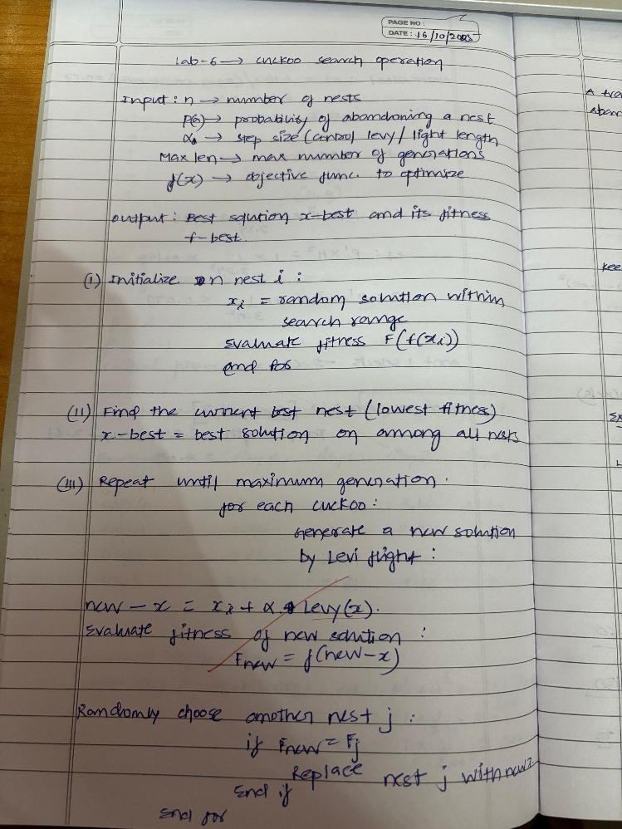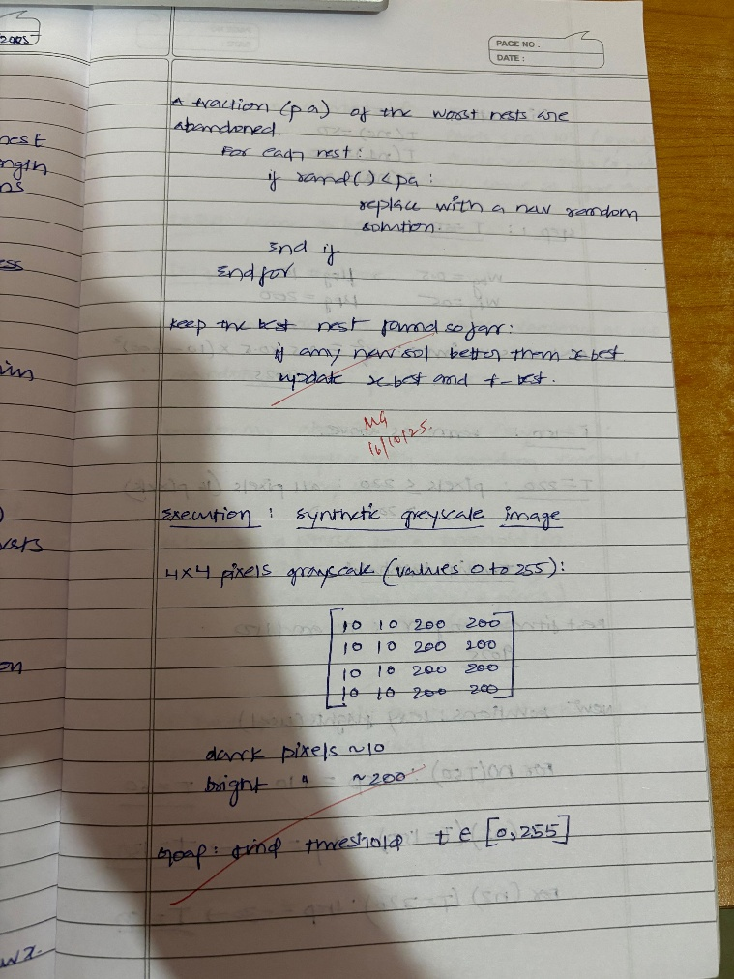

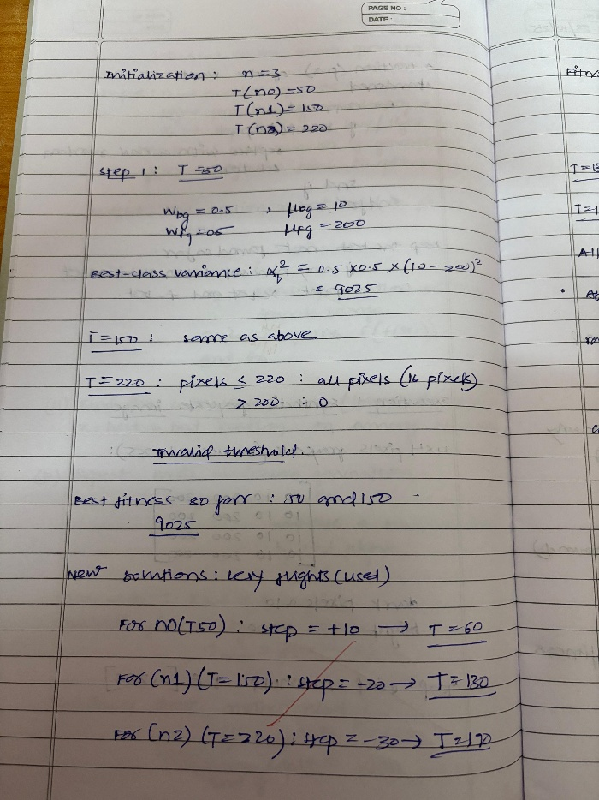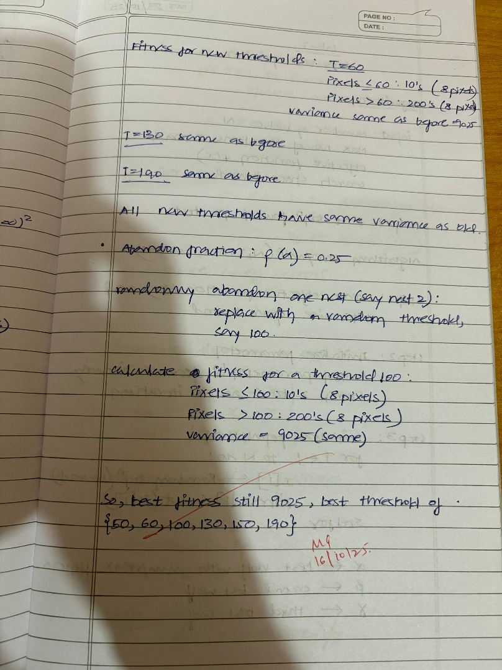

**Code:**

import random import math weights = [10, 20, 30, 40, 15, 25, 35] values = [60, 100, 120, 240, 80, 150, 200] capacity = 100 # Max weight capacity of the truck n_items = len(weights) n_nests = 15 max_iter = 50 pa = 0.25 def fitness(solution):

total_weight = sum(w for w, s in zip(weights, solution) if s == 1) total_value = sum(v for v, s in zip(values, solution) if s == 1) if total_weight > capacity:

return 0 # Penalize overweight solutions else:

return total_value def generate_nest():

return [random.randint(0, 1) for _ in range(n_items)] def levy_flight(Lambda=1.5):

sigma_u = (math.gamma(1 + Lambda) * math.sin(math.pi * Lambda / 2) /

(math.gamma((1 + Lambda) / 2) * Lambda * 2 ** ((Lambda - 1) / 2))) ** (1 / Lambda)

u = random.gauss(0, sigma_u) v = random.gauss(0, 1) step = u / (abs(v) ** (1 / Lambda))

return step def get_cuckoo(nest, best_nest):

new_nest = [] for xi, bi in zip(nest, best_nest):

step = levy_flight() val = xi + step * (xi - bi) s = 1 / (1 + math.exp(-val)) new_val = 1 if s > 0.5 else 0 new_nest.append(new_val) return new_nest def cuckoo_search():

nests = [generate_nest() for _ in range(n_nests)] fitness_values = [fitness(nest) for nest in nests] best_index = fitness_values.index(max(fitness_values)) best_nest = nests[best_index][:] best_fitness = fitness_values[best_index] for _ in range(max_iter): for i in range(n_nests):

new_nest = get_cuckoo(nests[i], best_nest) new_fitness = fitness(new_nest) if new_fitness > fitness_values[i]: nests[i] = new_nest fitness_values[i] = new_fitness for i in range(n_nests): if random.random() < pa: nests[i] = generate_nest() fitness_values[i] = fitness(nests[i])

current_best_index = fitness_values.index(max(fitness_values)) current_best_fitness = fitness_values[current_best_index] if current_best_fitness > best_fitness: best_fitness = current_best_fitness best_nest = nests[current_best_index][:] return best_nest, best_fitness if __name__ == "__main__":

best_solution, best_value = cuckoo_search() total_weight = sum(w for w, s in zip(weights, best_solution) if s == 1) print(f"Best packing solution (1 = selected): {best_solution}") print(f"Total value of supplies packed: {best_value}") print(f"Total weight: {total_weight}")

## Program 6 : Grey Wolf Optimization

**Problem statement:**

The Grey Wolf Optimizer (GWO) algorithm is a swarm intelligence algorithm inspired by the social hierarchy and hunting behavior of grey wolves. It mimics the leadership structure of alpha, beta, delta, and omega wolves and their collaborative hunting strategies. The GWO algorithm uses these social hierarchies to model the optimization process, where the alpha wolves guide the search process while beta and delta wolves assist in refining the search direction. This algorithm is effective for continuous optimization problems and has applications in engineering, data analysis, and machine learning.

**Algorithm:**

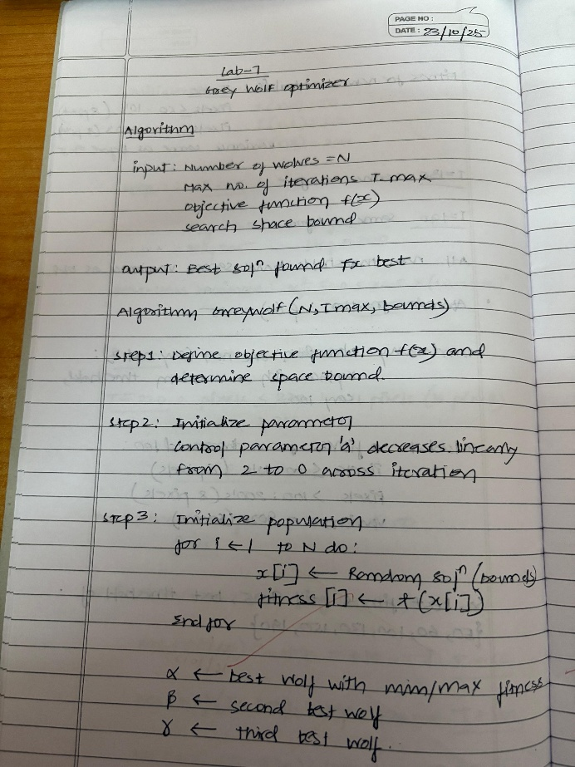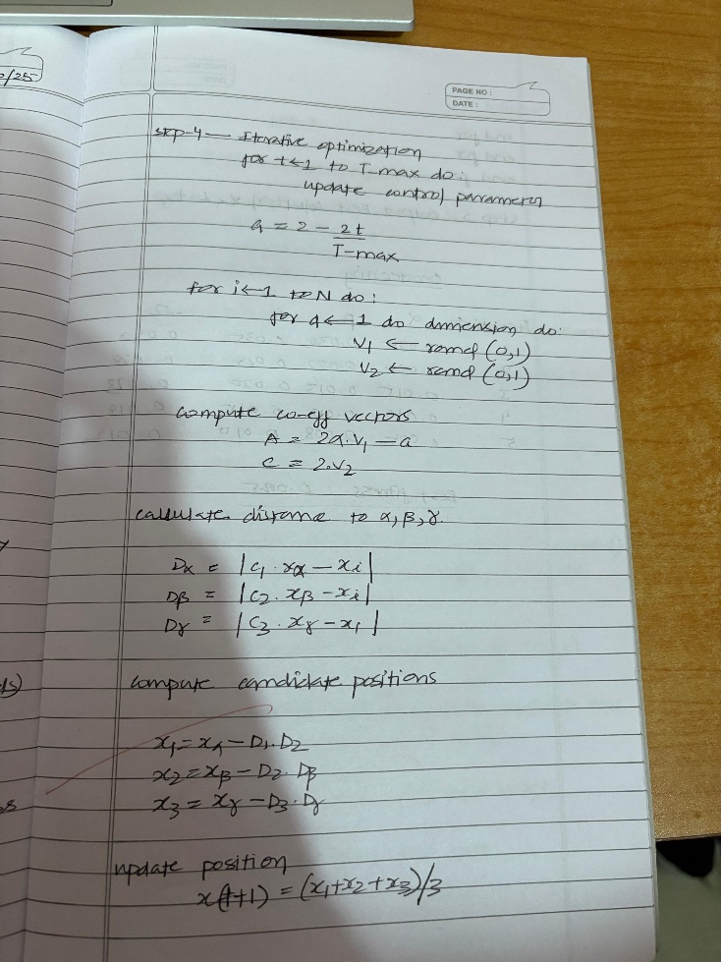

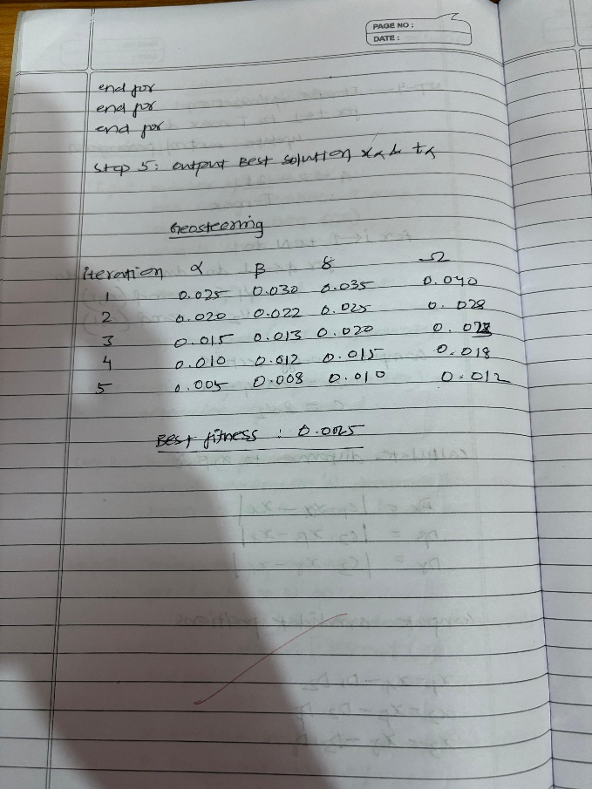

**Code:**

import numpy as np def gwo(obj_func, dim, search_space, n_agents=20, max_iter=100):

lb, ub = search_space wolves = np.random.uniform(lb, ub, (n_agents, dim)) alpha, beta, delta = None, None, None alpha_score, beta_score, delta_score = float("inf"), float("inf"), float("inf") for t in range(max_iter): for i in range(n_agents):

fitness = obj_func(wolves[i]) if fitness < alpha_score:

delta_score, delta = beta_score, beta beta_score, beta = alpha_score, alpha alpha_score, alpha = fitness, wolves[i].copy() elif fitness < beta_score:

delta_score, delta = beta_score, beta beta_score, beta = fitness, wolves[i].copy() elif fitness < delta_score:

delta_score, delta = fitness, wolves[i].copy() a = 2 - 2 * (t / max_iter) for i in range(n_agents): for j in range(dim):

r1, r2 = np.random.rand(), np.random.rand()

A1, C1 = 2 * a * r1 - a, 2 * r2

D_alpha = abs(C1 * alpha[j] - wolves[i][j]) X1 = alpha[j] - A1 * D_alpha

r1, r2 = np.random.rand(), np.random.rand()

A2, C2 = 2 * a * r1 - a, 2 * r2

D_beta = abs(C2 * beta[j] - wolves[i][j]) X2 = beta[j] - A2 * D_beta

r1, r2 = np.random.rand(), np.random.rand()

A3, C3 = 2 * a * r1 - a, 2 * r2

D_delta = abs(C3 * delta[j] - wolves[i][j])

X3 = delta[j] - A3 * D_delta

wolves[i][j] = np.clip((X1 + X2 + X3) / 3, lb, ub) return alpha, alpha_score grid_size = (20, 20) start, goal = np.array([0, 0]), np.array([19, 19]) obstacles = [

(5, 5, 10, 10),

(12, 0, 14, 14),

(3, 15, 15, 17)

]

def is_collision(point): x, y = point.astype(int) if x < 0 or y < 0 or x >= grid_size[0] or y >= grid_size[1]:

return True for ox1, oy1, ox2, oy2 in obstacles: if ox1 <= x <= ox2 and oy1 <= y <= oy2: return True return False

waypoints = waypoints.reshape(-1, 2) path = [start] + [w.astype(int) for w in waypoints] + [goal] total_dist, penalty = 0, 0 for i in range(len(path) - 1):

dist = np.linalg.norm(path[i + 1] - path[i])

total_dist += dist if is_collision(path[i + 1]):

penalty += 100

energy = 0 for i in range(1, len(path) - 1): v1 = path[i] - path[i - 1] v2 = path[i + 1] - path[i] if np.linalg.norm(v1) > 0 and np.linalg.norm(v2) > 0:

cos_angle = np.dot(v1, v2) / (np.linalg.norm(v1) * np.linalg.norm(v2)) angle = np.arccos(np.clip(cos_angle, -1, 1)) energy += angle return total_dist + energy * 5 + penalty n_waypoints = 5 # intermediate waypoints dim = n_waypoints * 2 best_path, best_score = gwo(path_cost, dim, (0, grid_size[0]-1), n_agents=30, max_iter=200) best_waypoints = best_path.reshape(-1, 2).astype(int)

final_path = np.vstack([start, best_waypoints, goal]) clean_path = [] for p in final_path:

pt = tuple(map(int, p)) if len(clean_path) == 0 or pt != clean_path[-1]:

clean_path.append(pt) print("Best Path Found:") for p in clean_path:

print(p) print("\nPath Cost:", round(best_score, 2))

## Program 7 : Parallel cellular Optimization

**Problem statement:**

Parallel Cellular Algorithms are inspired by the functioning of biological cells that operate in a highly parallel and distributed manner. These algorithms leverage the principles of cellular automata and parallel computing to solve complex optimization problems efficiently. Each cell represents a potential solution and interacts with its neighbors to update its state based on predefined rules. This interaction models the diffusion of information across the cellular grid, enabling the algorithm to explore the search space effectively. Parallel Cellular Algorithms are particularly suitable for large-scale optimization problems and can be implemented on parallel computing architectures for enhanced performance.

**Algorithm:**

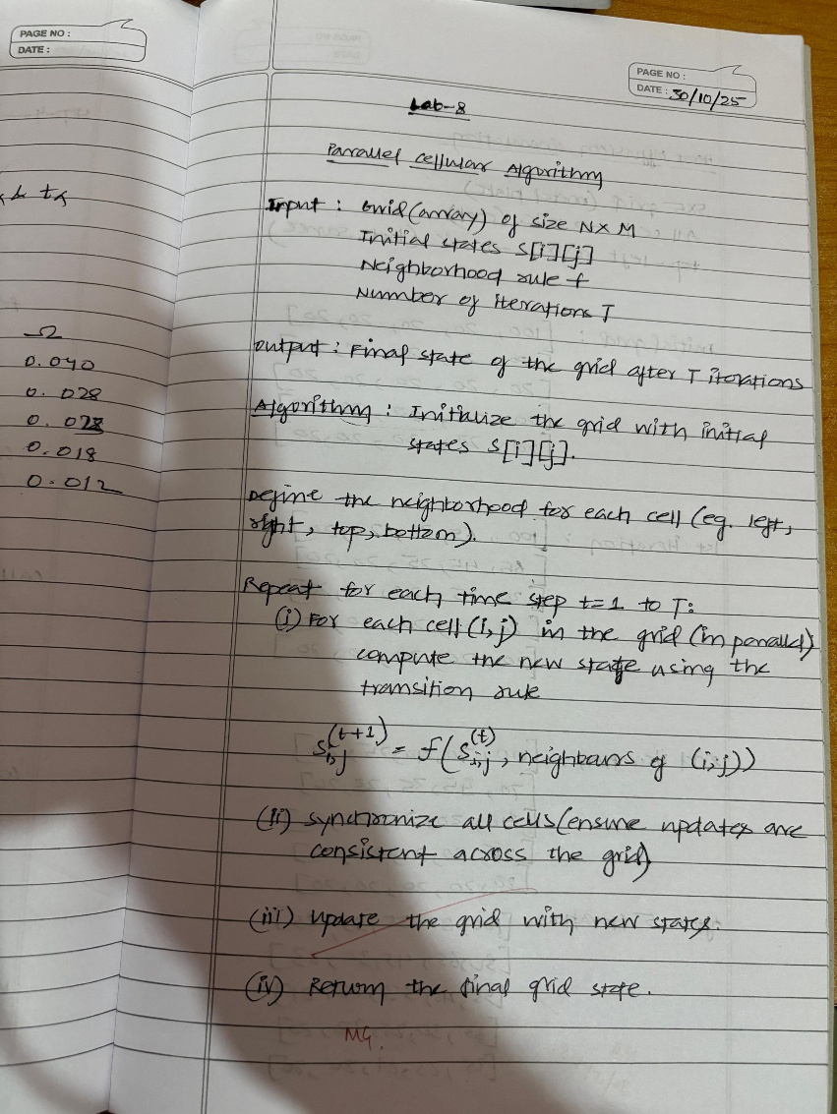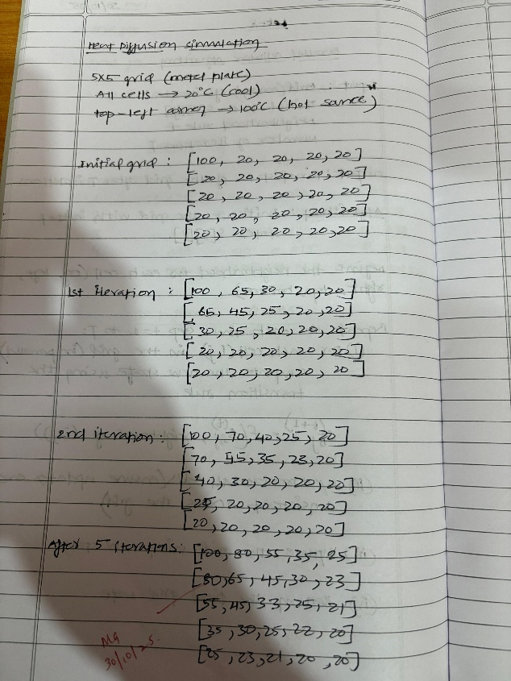

**Code:**

import numpy as np import random from itertools import permutations

distance_matrix = np.array([

[0, 2, 9, 10],

[2, 0, 6, 4],

[9, 6, 0, 8],

[10, 4, 8, 0]

])

num_customers = distance_matrix.shape[0] - 1 population_size = 9 grid_dim = (3, 3) num_vehicles = 2 def generate_individual(): perm = list(range(1, num_customers + 1)) random.shuffle(perm)

return perm population = [generate_individual() for _ in range(population_size)] def fitness(individual): split_points = np.linspace(0, num_customers, num_vehicles + 1, dtype=int) total_distance = 0 for i in range(num_vehicles):

route = [0] + individual[split_points[i]:split_points[i+1]] + [0] # depot at start and end for j in range(len(route) - 1):

total_distance += distance_matrix[route[j], route[j+1]] return total_distance def get_neighbors(idx):

r, c = divmod(idx, grid_dim[1]) neighbors = [] for dr in [-1, 0, 1]: for dc in [-1, 0, 1]:

nr, nc = r + dr, c + dc if 0 <= nr < grid_dim[0] and 0 <= nc < grid_dim[1]:

n_idx = nr * grid_dim[1] + nc if n_idx != idx:

neighbors.append(n_idx)

return neighbors def crossover(parent1, parent2):

size = len(parent1) a, b = sorted(random.sample(range(size), 2)) child = [None] * size child[a:b] = parent1[a:b] pointer = b for gene in parent2[b:] + parent2[:b]: if gene not in child: if pointer == size:

pointer = 0 child[pointer] = gene pointer += 1 return child def mutate(individual):

a, b = random.sample(range(len(individual)), 2) individual[a], individual[b] = individual[b], individual[a] return individual def pca_iteration(pop): new_pop = pop.copy() for idx in range(len(pop)):

neighbors = get_neighbors(idx) partner_idx = random.choice(neighbors)

parent1 = pop[idx] parent2 = pop[partner_idx] child = crossover(parent1, parent2) if random.random() < 0.2: child = mutate(child) if fitness(child) < fitness(pop[idx]):

new_pop[idx] = child

return new_pop num_generations = 25 for gen in range(num_generations):

population = pca_iteration(population) best_fitness = min(fitness(ind) for ind in population) print(f"Generation {gen+1}: Best total distance = {best_fitness}") best_individual = min(population, key=fitness) print("\nBest route assignment (split evenly):") split_points = np.linspace(0, num_customers, num_vehicles + 1, dtype=int) for i in range(num_vehicles):

route = [0] + best_individual[split_points[i]:split_points[i+1]] + [0] print(f"Vehicle {i+1} route: {route}")

print(f"Total distance: {fitness(best_individual)}")